**UNITY III**

**ACTIVITY 2**

**DESCRIPTION OF MEALS AND MENU**

**JULIETH CATHERINE ORTEGA MENDOZA**

**COD: 1049636518**

**TUTOR**

**LILIANA HERNANDEZ AMADO**

**UNIVERSITY FOUNDATION SAN MATEO**

**BASIC ENGLISH MODULE**

**SAFETY AND HEALTH ENGINEERING FOR WORK**

**2019**

1. **RESTAURANTE MI PUEBLO**

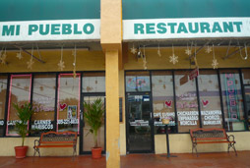

**AUDIO**

<https://www.dropbox.com/s/vd69wjabyw6k49m/restaurant%20mi%20pueblo.mp3?dl=0>

1. **ORDENAR LAS PALABRAS**

**May/ how/ you / I / help/Do/want/drink/you/what/to/?**

* How may I help you, what do you want to drink?

¿En qué puedo ayudarte? ¿Qué quieres beber?

**AUDIO**

[**https://www.dropbox.com/s/su8uw0gvf84ytd0/questions.mp3?dl=0**](https://www.dropbox.com/s/su8uw0gvf84ytd0/questions.mp3?dl=0)

1. **Complete el siguiente diálogo, teniendo en cuenta las opciones ofrecidas:**

**You / Restaurant / Twenty / Order / Eggs / Coffee / Can/ Is**

Hello welcome to the restaurant

- Mr. what can I do for you?

- Thank you

- Give me some eggs and a cup of coffee

- Yes sir here is your order

- Thanks is delicious

- How much is it?

- It is just twenty dollars

- Ok here is the money thanks